**Protection of information based on sensitivity and privilege levels**

**CS3052 - Computer Security**

**190145G – W.A.M. Dilshan**

# The program codes

import csv

import hashlib

# mapping of privileges to privilege levels

read_privileges = {

    'patient' : ['record_id','user_name','personal_details','sickeness_details','drug_prescriptions','lab_test_prescriptions'],

    'lab staff' : ['record_id','user_name','personal_details','lab_test_prescriptions'],

    'pharmacy staff' : ['record_id','user_name','personal_details','drug_prescriptions'],

    'nurse' : ['record_id','user_name','personal_details','sickeness_details','drug_prescriptions','lab_test_prescriptions'],

    'doctor' : ['record_id','user_name','personal_details','sickeness_details','drug_prescriptions','lab_test_prescriptions']

}

allowed_actions = {

    'patient' : ['view my records'],

    'lab staff' : ['view all records', 'view all records by user name', 'view record by id'],

    'pharmacy staff' : ['view all records', 'view all records by user name', 'view record by id'],

    'nurse' : ['view all records', 'view all records by user name', 'view record by id'],

    'doctor' : ['view all records', 'view all records by user name', 'view record by id', 'add new record']

}

# hashing the given string using md5

def hash(str_to_hash):

    return hashlib.md5(str_to_hash.encode()).hexdigest()

# reading the config csv and store the data in the 2d array

def read_csv(filename):

    data= []

    with open(filename,"r") as file:

        csvreader = csv.reader(file,delimiter=",")

        for row in csvreader:

            if row:

                data.append(row)

    return data

# writing a one row data to csv

def write_csv(filename,data):

    with open(filename,"a") as file:

        csvwritter = csv.writer(file)

        csvwritter.writerow(data)

# validating if a given user exists already

def validate_user_exists(user_details,username):

    for user_data in user_details:

        if user_data[0] == username:

            return True,user_data

    return False,[]

# function to handle login

def login():

    username = input("Enter your username: ")

    is_username_valid, user_data = validate_user_exists(user_details,username)

    if not is_username_valid:

        while True:

            choice = input("Entered username is invalid!\nPlease select a choice to continue: \n1 - Re-enter the login details\n2 - Go to main menu\n")

            if choice == "1":

                return login()

            elif choice == "2":

                return False,[]

            else:

                print("Incorrect input. Please try again!\n")

    password = input("Enter your password: ")

    if not user_data[1] == hash(password):

        while True:

            choice = input("Entered username is invalid!\nPlease select a choice to continue: \n1 - Re-enter the login details\n2 - Go to main menu\n")

            if choice == "1":

                login()

            elif choice == "2":

                return False,[]

            else:

                print("Incorrect input. Please try again!\n")

    print("Login successfull!")

    return True,user_data

# function to handle registeration

def register():

    global user_details

    username = input("Enter a username: ")

    is_user_valid,_ =  validate_user_exists(user_details,username)

    if is_user_valid:

        print("This username already exists. Please try a different one.")

        return register()

    password = input("Enter a password: ")

    hashed_password = hash(password)

    valid_user_type = False

    while not valid_user_type:

        user_type_choice = input("Enter the user type:\n1 - Patient\n2 - Hospital staff\n")

        valid_user_type = True

        if user_type_choice == "1":

            user_type = "patient"

        elif user_type_choice == "2":

            user_type = "hospital staff"

        else:

            print("Invalid input! Please try again.")

    if user_type == "patient":

        privilege_level = "patient"

    else:

        valid_privilege_level = False

        while not valid_privilege_level:

            privilege_level_choice = input("Enter your privilege level:\n1 - Lab staff\n2 - Pharmacy staff\n3 - Nurse\n4 - Doctor\n")

            valid_privilege_level = True

            if privilege_level_choice == "1":

                privilege_level = "lab staff"

            elif privilege_level_choice == "2":

                privilege_level = "pharmacy staff"

            elif privilege_level_choice == "3":

                privilege_level = "nurse"

            elif privilege_level_choice == "4":

                privilege_level = "doctor"

            else:

                print("Invalid input! Please try again.")

    user_data = [username,hashed_password,user_type,privilege_level]

    user_details.append(user_data)

    write_csv("config.csv",user_data)

    print("Registration successfull!")

    return True

# adding a new record

def add_record():

    record_id = str(len(record_details)+1)

    username = input("Enter the patient username: ")

    is_user_valid,_ =  validate_user_exists(user_details,username)

    if not is_user_valid:

        print("This patient is not exist! please re-enter")

        return add_record()

    patient_details = input("Enter the patient details: ")

    sickness_details = input("Enter the sickness details: ")

    drug_description = input("Enter the drug description: ")

    lab_test_prescriptions = input("Enter the lab test prescriptions: ")

    record = [record_id,username,patient_details,sickness_details,drug_description,lab_test_prescriptions]

    write_csv("record.csv",record)

    record_details.append(record)

# getting records using record id

def get_record_by_id(id):

    return record_details[id-1]

# getting records using patient username

def get_records_by_username(username):

    output = []

    for record in record_details:

        if record[1] == username:

            output.append(record)

    return output

# helper function to show records to filter the fields in the records.

def filter_record(records,user_privilege):

    if user_privilege == "lab staff":

        for record in records:

            record.pop(4)

    elif user_privilege == "pharmacy staff":

        for record in records:

            record.pop(3)

    return records

# function to print the records with the filtering.

def show_records(records,user_privilege):

    print("Here the medical records!")

    filtered_records = filter_record(records,user_privilege)

    for record in filtered_records:

        print(" ".join(record))

    return

# generating action menu for given actions.

def generate_menu(actions):

    menu ="select a choice from below options.\n"

    i = 0

    for action in actions:

        i += 1

        menu += str(i)+"- "+action+"\n"

    return menu

# this will run given command with username and user privilege. This where user's actions running after login and they selects a action.

def do_action(action,username,user_privilege):

    if action == "view my records":

        records = get_records_by_username(username)

        show_records(records,user_privilege)

    elif action == "view all records":

        show_records(record_details,user_privilege)

    elif action == "view all records by user name":

        req_username = input("Enter the username of the patient: ")

        records = get_records_by_username(req_username)

        show_records(records,user_privilege)

    elif action == "view record by id":

        id = int(input("Enter the record ID: "))

        record = get_record_by_id(id)

        show_records([record],user_privilege)

    elif action == "add new record":

        add_record()

# loading neccessary data

user_details = read_csv("config.csv")

record_details = read_csv("record.csv")

# Here the main function

def main():

    is_validate_option = False

    user_data = []

    while(not (is_validate_option and user_data )):

        option = input("Select a relevent number for login or register\n1 - Login\n2 - Register\n")

        if option == "1":

            is_validate_option,user_data=login()

        elif option == "2":

            is_validate_option= register()

        else:

            print("Invalid input. Please enter again choice 1 or 2.\n")

    username,user_type,user_privilege = user_data[0],user_data[2],user_data[3]

    actions = allowed_actions[user_privilege]

    menu = generate_menu(actions)

    while True:

        print(menu)

        choice = int(input("Enter your choice: "))

        if 1<=choice<=len(actions):

            do_action(actions[choice-1],username,user_privilege)

        else:

            print("Invalid input")

# running the main function.

main()

# A description of how you decided the access to data records based on sensitivity of data

There are three sensitivity levels in the program data set

1. Low sensitivity
2. Medium sensitivity
3. High sensitivity

For each sensitivity level has list of data fields such as

low= ['record_id','user_name','personal_details'],

medium=['drug_prescriptions','lab_test_prescriptions'],

high= ['sickeness_details']

After the user login then program will generate the relevant action menu using the user privilege and then user will be able to select any option from the menu. Filtering happening according to the level of sensitivity. Write record only set to doctor.

# Annexes

Config file

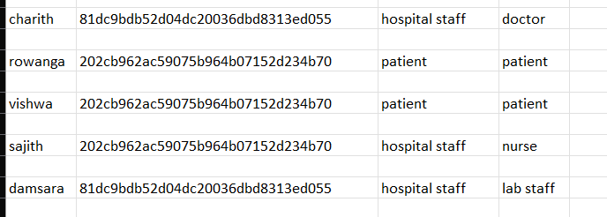

Records file

Login as a patient

Register as a doctor

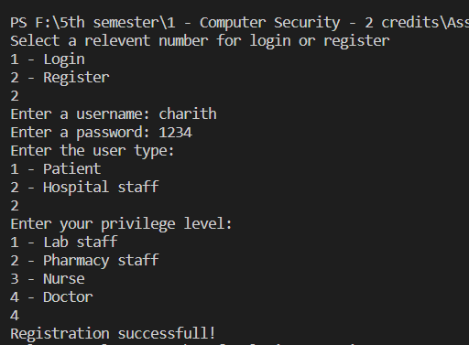

Register as a patient

Adding a new record and view all records as a doctor

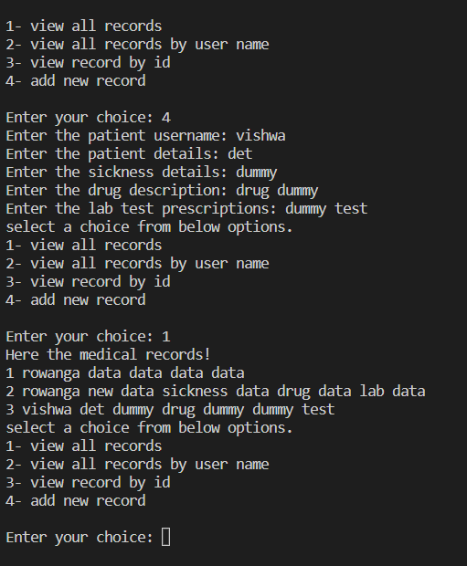

View all records as a nurse

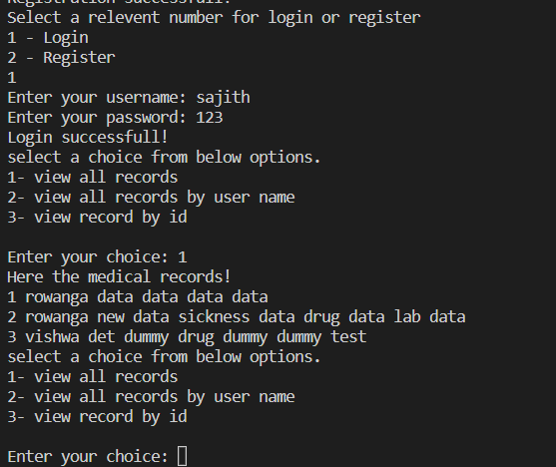

View all records as a lab staff

